Individual Project Deliverable: Low-Fidelity Wireframe

**Instruction:**

* Students will create 6-8 low-fidelity wireframes, such as: a representative page (or pages) from your project site map, an example of a type of page (or examples of different types of pages) and a sequence of pages selected from your sitepath.
* Students need to include notations (either as numbered footnotes or directly within the wireframe), explaining the various elements included in their wireframe and providing additional information about choices and decisions made (such as where the content comes from, the nature of the content, whether an element is required, optional, and/or conditional, etc.).
* Remember, as per our readings, Low fidelity wireframes include the most basic content and visuals and are usually static (not interactive). Several low­fidelity wireframing tools exist that can help you reproduce the experience of sketching on a whiteboard, but using a computer. Making mockups with these tools is fast, and it is easy to generate more ideas so you can throw out the bad ones and discover the best solutions.  
  Recommended tools: balsamiq or Lucid chart
* You may provide a few sentences to guide what is being illustrated

1. **Homepage Wireframe:**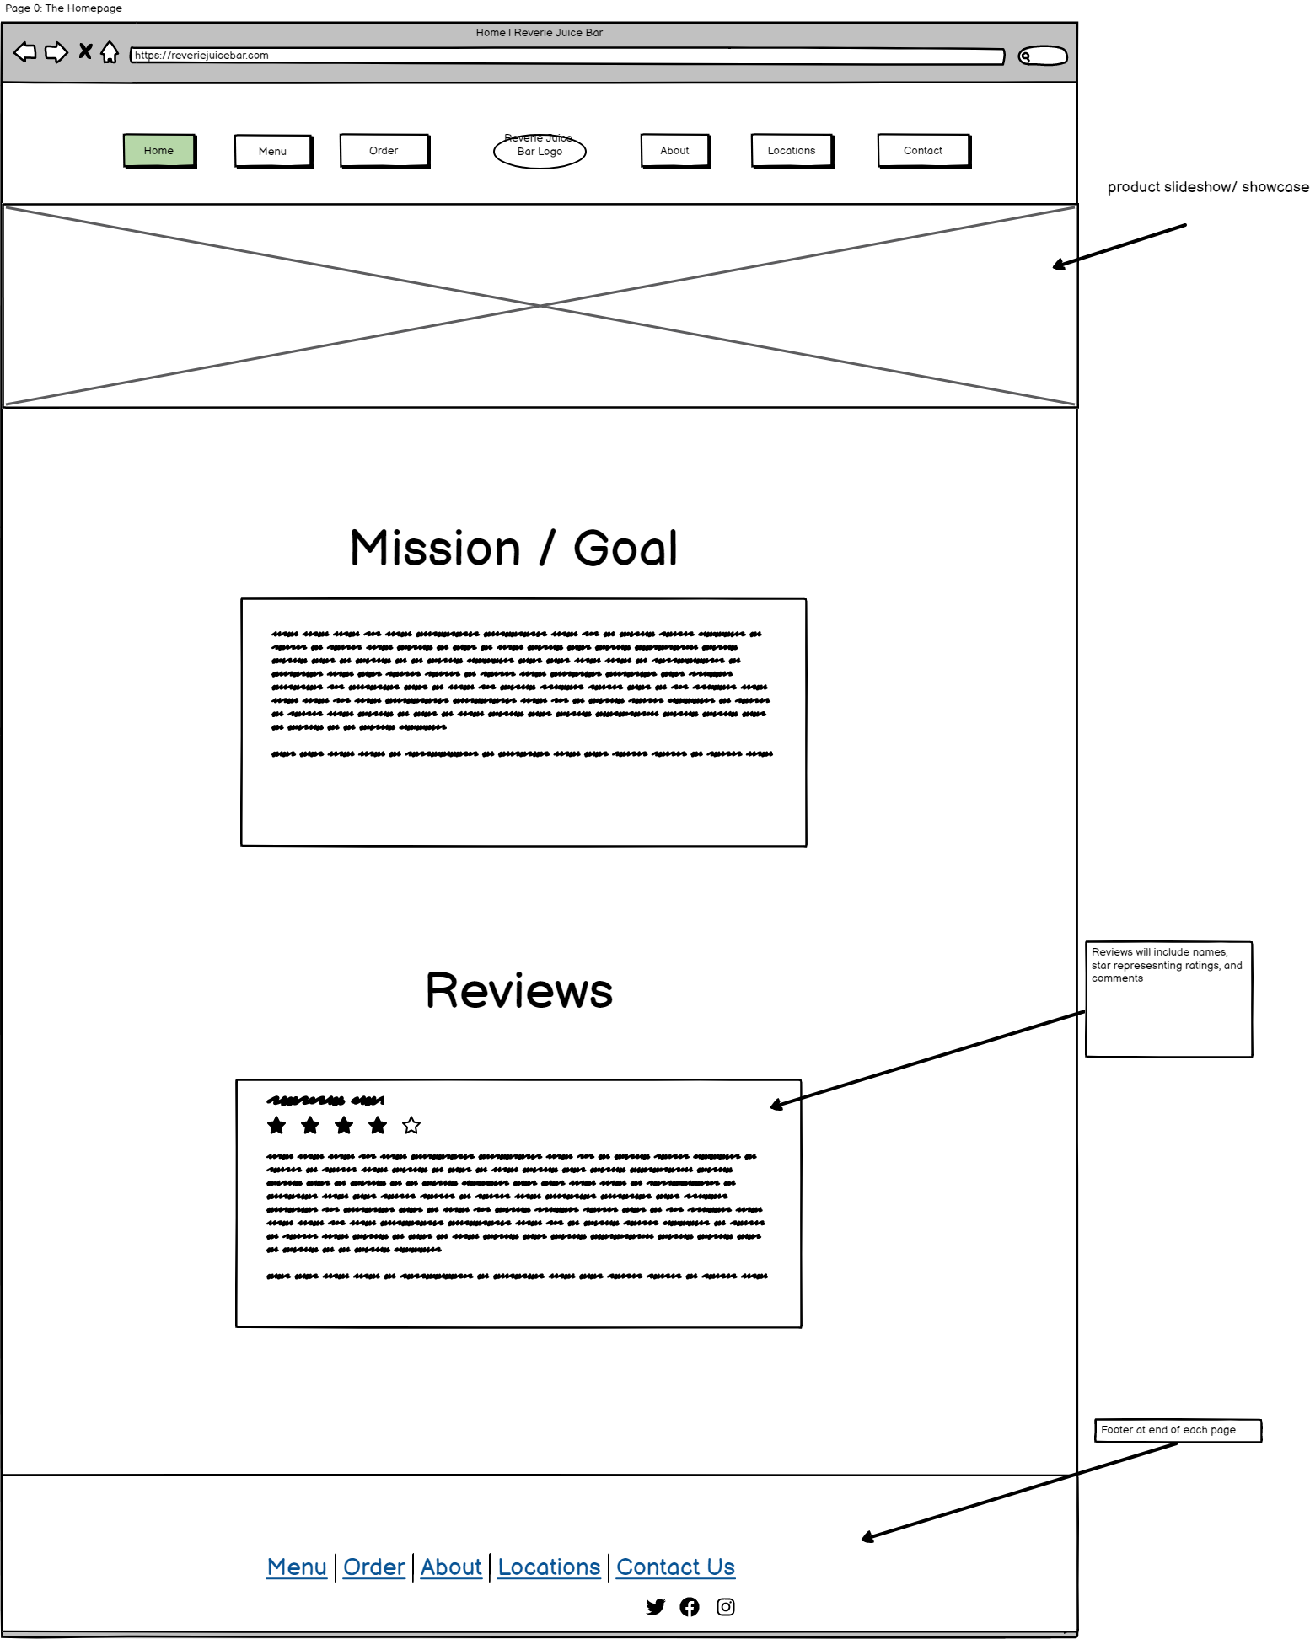
2. **Contact Page**

